**ATHLETICS HUB ORIENTATION**

[**Log in - Athletics Hub**](https://www.athleticshub.co.uk/login?s_id=6aeed9408a6c29591c0788f7069d33ad)

**Enter URN Number e.g., 1234567 or your email address, followed by your password**

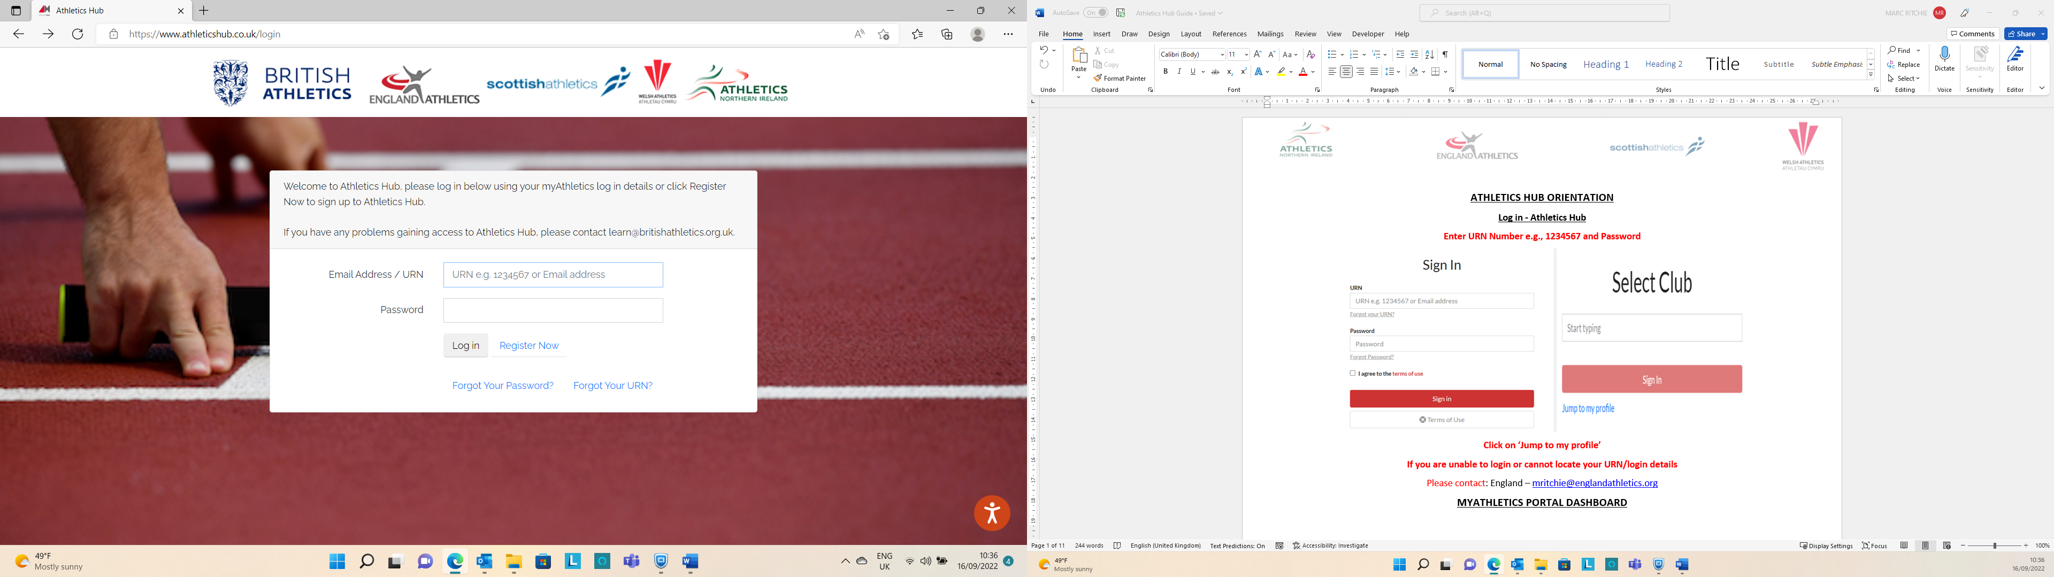

**Click ‘Log In’**

**If you are unable to login or cannot locate your URN/login details**

**ATHLETICS HUB DASHBOARD**

**INDIVIDUALS WILL NOT HAVE ANY ADMIN FUNCTIONALITY AS REFERENCED IN THE ABOVE DIAGRAM**

**UPDATING PERSONAL DETAILS > CLICK ON YOUR NAME AT TOP OF MENU > AMEND THE DETAILS > SUBMIT**

**SEARCHING FOR CALL ROOM MODULE**

**CLICK ON ‘QUALIFICATIONS & CPD’ ON LEFT-HAND SIDE MENU**

**Click on down arrow under ‘*what’* > select ‘call room module’ > Search**

**STEP 2 – BOOKING ONTO CALL ROOM MODULE**

**Click on ‘Book Now’**

**Tick boxes for booking and licensing terms and conditions to continue.**

**The call room module will now be added to your officials’ course resources.**

**This can be access by Online Courses > Go to My Learning > My Courses**

**A certificate will be generated that can be downloaded following completion of the module itself.**

**ACCESSING COURSE MATERIAL**

You may see the below message appear at the top of the page

To fix this you might see one of the following symbols at the top of your screen

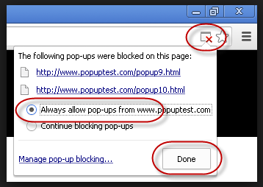

Do not worry about this. Then follow the below steps then click the refresh button to see your resources

